Senior Minister Search
Candidate – John Blackmore
March 2025

Contents
Bio 1
McKnight Sermon: 1
John Blackmore – Verbal/Email Feedback Summary 2
John Blackmore – Google Forms Survey 8
Contact with Candidate: 8
Section 1: Sermon and Teaching – How engaging and relevant was the sermon? 8
Section 1: Sermon and Teaching - Was the message clear and biblically sound? 10
Section 2: Connection with the Congregation - How well did the candidate relate to different groups in our church? 11
Section 2: Connection with the Congregation - Was the candidate approachable and personable? 12
Section 3: Overall Impression - Do you feel the candidate would be a good fit for our church? 14
Additional Thoughts or Concerns 16
Candidate Preference 18
Excel Spreadsheet of Google Form Survey 19

Bio:
John currently lives in Sullivan, Missouri with his wife, Laura, and has two adult sons.

McKnight Sermon:
John Blackmore preached to the McKnight Crossings Sunday church on, March 9, 2025. The sermon was on “Know Your Mission”, and the video is available on YouTube here - https://www.youtube.com/watch?v=tF7vjMZmq60&t .

John Blackmore – Verbal/Email Feedback Summary
March 9 weekend feedback

Below are comments received verbally or via email (not collected on survey form - https://docs.google.com/forms/d/1eNnW5VTXMVsrVmduWoZNZu-O9PEMKlVM8NBETgFs8sk/edit .

From | Comments
Matthew Bardowell | Dear Elders,  I wanted to send you an email to express my thoughts on John Blackmore. I urge you not to offer John the lead minister position.  I was with the kids during the sermon, but I have now listened to his sermon on YouTube. I did attend his Sunday School Class, and I spoke with him afterwards to ask a few questions. I like John as a person, and, of course, I regard him as a brother in Christ. But I think it's important to separate that from whether he is the right fit for our church. And I don't believe he is the right fit.  I would love to get together with you all, to discuss my thoughts in more depth, but for now, let me offer the following outline of my concerns.  1. His sermon showed a lack of discipline. At this stage in a minister's career, I would expect a fairly well-structured presentation of the gospel with some particular focus. There was a good deal of wandering and rambling and a fair bit of self-indulgence in the extemporaneous manner of his delivery. We want a lead minister who can offer a message that is compelling to visitors and edifying to the body of Christ. Based on his presentation, I don't think we could reasonably expect this if we were to hire him. As I'm sure you know, people are usually on their very best behavior in an interview setting. The length of John's sermon and class show, at best, a lack of discipline and, at worst, a concerning lack of humility to modify his approach to suit the needs of our congregation. John seemed to be aware that he goes long; he just didn't seem to care. It's this disregard that concerns me about his ability to humbly accept parameters.  2. His Sermon and Sunday School class raised some cultural red flags. I spoke to a few of you to ask whether John would be comfortable with the way we do things at MX, specifically meaning the ways MX differs from other Churches of Christ. The folks I spoke with assured me that he would be fine, but John said some things that gave me reservations about how well he would fit within the culture of our congregation. First, I would ask him directly whether he believes that the decision the church has reached on women's roles is an error. In his Sunday School class, he framed our stance of women's roles as "something you are working through." I don't think this is accurate. It is a decision this church has made after study and prayer. Yes, we are open to the promptings of the Spirit on matters we feel are decided, but I felt it was disingenuous to frame our stance on women's roles as something in progress, and it may hint that he hopes we are malleable enough for him to shape as he deems right.  In his sermon, he expressed sadness that we were three generations out from being a Christian nation. By this, he seemed to mean that we have drifted from God's ways in the past three generations, when cultural Christianity was prevalent. But we must be clear-eyed on this point. Cultural Christianity is not necessarily true Christianity. What was happening in this nation three generations ago? I doubt that those who had to eat in segregated restaurants would say that they lived in a Christian nation. This mentality is concerning because it longs for a past that looked like Mayberry. A past in which most people went to church on Sundays but could maintain their petty prejudices under the sanction of the church. We must look forward, not backwards. Either John has embraced this idea or he is unaware of the implications. Whatever the case, it makes him poorly suited to lead our congregation.  For these reasons, I don't think John is the right candidate to lead MX into the future. In the coming years, we, as a church, will no doubt be faced with many challenges. We need someone with a clear-eyed awareness of those challenges and someone who is equipped to lead us through them. I also want to say that, in my view, we had three excellent candidates for this position who sadly turned it down. I did not have these reservations about any of those candidates. I truly felt that we could not really have gone wrong in deciding between the last two candidates. I feel that we can go wrong here, and I would not approach you with these concerns if I didn't feel they were significant.  Let me close by saying how grateful I am to each of you. I know this has been a hard job. I know the road to finding a new minister has been bumpy and that there have been many setbacks. I imagine that everyone is ready to be finished with this job search. I hope that we as a church do not become desperate. Stay the course. Stay true to your vision for this position. God will meet this need. Please know that I am here and willing to help as needs arise.  Please let me know if you would like to meet to discuss this further. I'd be happy to speak with you.  Love you guys,  Matthew
Steve Jones | We listened to John’s sermon driving home from Ozark MO today. Almost made it to St Charles before he wrapped it up!😜  Sounded good and I didn’t fall asleep at the wheel but per his comment maybe we need a clock in auditorium.  I’m a little concerned about his age as I’m sure you don’t want to be searching again in a few years. Is he willing to move and is he in our price range?
Jayson Vincent | On Mar 9, 2025, at 7:03 PM, Jayson Vincent <Jayson.t.vincent@gmail.com> wrote:  ﻿Thank you very much Brother Steve's (Walker & Awtrey) for the efforts to plan, invite, support, pray & more for the senior minister search, and for welcoming John & Laura this weekend.  We especially appreciate the opportunity for Wilka & I both to join, which required us bringing Naomi & Rosalie.  The way that John was willing to listen & apologize and dialogue after Gwen's thoughts was a highlight for us. Listening and adjusting are vital for our next servant in that role. There was also a great example set (for Jayson) in supporting my wife in a scenario such as yesterday. Thank you for that, always learning from you guys.  We also valued their flexibility & willingness to follow God as missionaries. And we valued their interest in continuing to participate in missions.  And we highly valued their focus on God's mission and God's word as a priority and a uniter, and we valued that they team together.  We thought it was a great sign that John acknowledged that someone like Nathan will have a better idea about how to reach more individuals his age than he himself would, and his willingness to do church differently if the next generation so leads so, and as a good thing.  We thought it was a great sign that Laura had already identified and spent time in the French organization a few miles away from MX.  There are experiences and perspectives that he is unable to fully understand or relate to, and he has that in common with many, and we felt his openness to learning & listening is likely. I think for all of us, there are experiences and perspectives that we can't understand or relate to. I feel that yourself and others already know this, but for us, as we grow older and reflect on our own experiences, we are learning this more & more. A minister's opportunity in this is to value relationships and to believe in the loving & saving & transforming power of Jesus, His Spirit, and His gospel. It's difficult to find a perfect candidate in this (rather, impossible) but we felt good about their chances.  We our sharing that we would support John joining as senior minister at mx.  We imagine you're processing thoughts from lots of members, and we appreciate your time on reading ours, as well as on all the leadership and service you guys continue to provide.  We're excited about where God's Spirit leads you, no matter what.  Alongside in prayer and in Christ,  Jayson & Wilka Vincent
Suzanne Kaelble | Hi Dave and all the elders,  I am wanting to give my response, for lack of a better word, to watching the service on YouTube this morning. I appreciated his enthusiasm. He seems to have a heart for missions. A couple things caused concern. I was confused by if he is very familiar with churches of Christ. He seemed to be coming from some kind of musical void with his reaction to the congregational singing. First he was surprised we had a piano (which would be a normal response from someone raised in a church of Christ) but then he didn’t seem familiar w the 4-part harmony of “Love One Another”. I didn’t sense any kind of appreciation on his part for the beauty of the song.  Probably what concerned me the most was his use of the phrase “evangelical Christian ”. In no way do I consider myself to be a part of what, in our country, is currently the evangelical Christians. To me, a person who calls himself or herself an evangelical Christian, implies a group of people that support a different picture of who I see the person of Jesus as being.  I also basically had some difficulty following the sermon. I know he prefaced it by saying he only had this one opportunity to say everything he wanted to say, so he certainly said a lot. He bounced around a lot with his topics.  I put a quote from Harriet Stowe on Facebook a while back. It said, paraphrased: I don’t know much about politics. What I read in my bible is I’m to care for the sick, the poor, the imprisoned. That’s the Bible I follow.  I know that you all were able to get a more well-rounded feel for him. I’m not comfortable with the possibility of him as the lead preacher for McKnight Crossings church of Christ based on his sermon today.  I don’t know if I expressed my reasons very clearly but I can’t think of any other way to say them.  Because God loves us all,  Suzanne Kaelble
Andy Clapper | Hi Elders,  Thanks for hosting a wonderful set of opportunities for the MX Congregation to hear from the new Minister candidate. As a part of the MX church, we felt it our responsibility to provide our feedback for your consideration:  Firstly, we enjoyed learning that John has St. Louis roots and is committed to the health of our metro area. That being said, we found John's message regarding the core principle of "missions" to be a bit convoluted, and it raised concerns about his approach to future Services and as the "face" of the Church. Despite preaching for ~50 minutes and covering scripture from Genesis to Revelations, we left the auditorium feeling a little bit lost as to how John would lead our church in the principle he chose to showcase for his interview. We were disappointed that as a missionary of 10 years, he really didn't share much about his experience and how he would apply those lessons to McKnight's congregation. To put it plainly, John didn't really show us the vulnerability I would have expected him to demonstrate in this opportunity, and it concerned us with how he'll connect with the congregation as a whole. Additionally, some of the things that he said seemed either culturally insensitive or less aware than we would expect for the congregation that MX has.  We are really excited about the potential to fill this role, and we know it has been a long road. However, this specific candidate does not "feel like McKnight" to us. Certain elements of John's presentation referenced very legalistic interpretations of the scripture, and used third party experiences (rather than personal ones) to make points. Although none of that is necessarily a bad thing, it does raise additional questions for us about ability to connect with other and fit inot the culture of community in the Service that the Church has worked so hard to foster.  I'm sure if John is selected for the role that we will grow to know and love his approach, but with this very limited exposure and the importance of the decision, we thought it prudent to share our thoughts.  Thanks,  Andy & Grace
Rachel Bardowell | Dear Elders,  I wanted to provide some feedback on the minister candidate. Firstly, thank you for your tireless efforts during the search process as I know it has gone on for longer than anticipated. I also appreciate your willingness to receive and consider the perspectives of various members. Our small group has been praying consistently for you all and about the process since we heard of Jeff’s plans to retire. I would like to share some concerns, however, that I have about this candidate that I did not have for any of the prior candidates.  I would like to start with the elephant in the room, which was the length of both the sermon and the class. Matthew and I were with the kids that day and I was surprised to hear him mention within his opening remarks when I went back to listen to the sermon, that he thought the people with the kids wouldn’t be happy with him. This tells me that he has chronic issues with time management in his speaking- which he has insight to, but after years of experience has not developed the skills to focus his remarks. This communicates, perhaps unintentionally, a lack respect for other people’s time or an inability to heed instructions. As an additional example, during class time, I recall Steve Walker telling him we could take 20 minutes for class since we were running late, but John again continued for twice this amount of time.  There were some remarks during the sermon that also made me question whether he would be the right choice for our congregation. The first of these remarks was about men being the head of the household, which lacked nuance. He made one or two other remarks that were more subtle that made me wonder if he was aligned with our practice and conclusions about how women serve in the church. I would request that you ask him directly about his opinions on this matter if this has not been discussed already. Other remarks that made me concerned that he would not be a good fit for our church included several negative comments about other denominations. I have always loved that we have welcomed members from different denominational backgrounds which I think has been in part because we have avoided sectarian rhetoric. Some of his comments about people attending church less in the modern day could have been viewed as romanticizing mid century American Christianity which is problematic in a city with deep racial injustices such as St Louis.  Overall, I doubt that John would be the right person to help us grow at this time in our history. I thought he was very friendly and is someone I would enjoy speaking to about his life experiences and I respect him as my brother in Christ. I appreciate the chance to candidly share my concerns, I will be praying for the process and your decisions.  Rachel
Steve Haupt | Hi guys,  If I was still an elder, he’d be starting next week. Lots of pluses:  - Scriptural lesson (easy to listen to and understand)  - Good presentation (spoke to us instead of at us)  - Outgoing and personable  - Plenty of experience  - Lives close by so is familiar and comfortable with this area of country  - He’s available and wants the job  - He’s affordable I’m assuming  - He can start soon  - His wife is “very” personable  - He has enough energy for 5+ more years  He’s not perfect….who is?  If there is an absolutely perfect candidate, he’s not available or affordable.  For as long as you’ve been actively looking, I believe you finally found the best candidate for McKnight.  Good job; now close the deal and move onto something easier🤪.  Blessings,  Steve
Glenda Smith | I felt that the first 20 to 25 minutes of his sermon was very good, but unfortunately after that my attention span is gone. If his normal sermons are that long, I am not in favor of hiring him.

John Blackmore – Google Forms Survey
Below information summarized from the Google Forms Survey sent to McKnight congregation in various email and bulletin communications - https://docs.google.com/forms/d/e/1FAIpQLSeaAK4dVym7h4fz4zy-Tt22dBSIzoniwJ6jmW5h1gDw-icGqQ/viewform?usp=sharing .

Contact with Candidate:

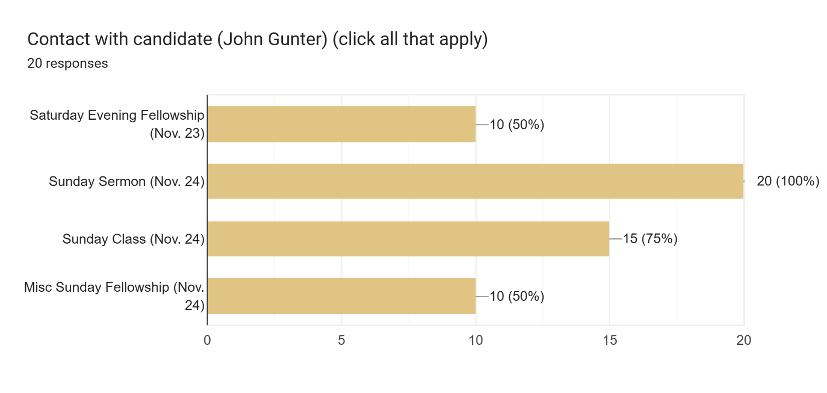

Section 1: Sermon and Teaching – How engaging and relevant was the sermon?

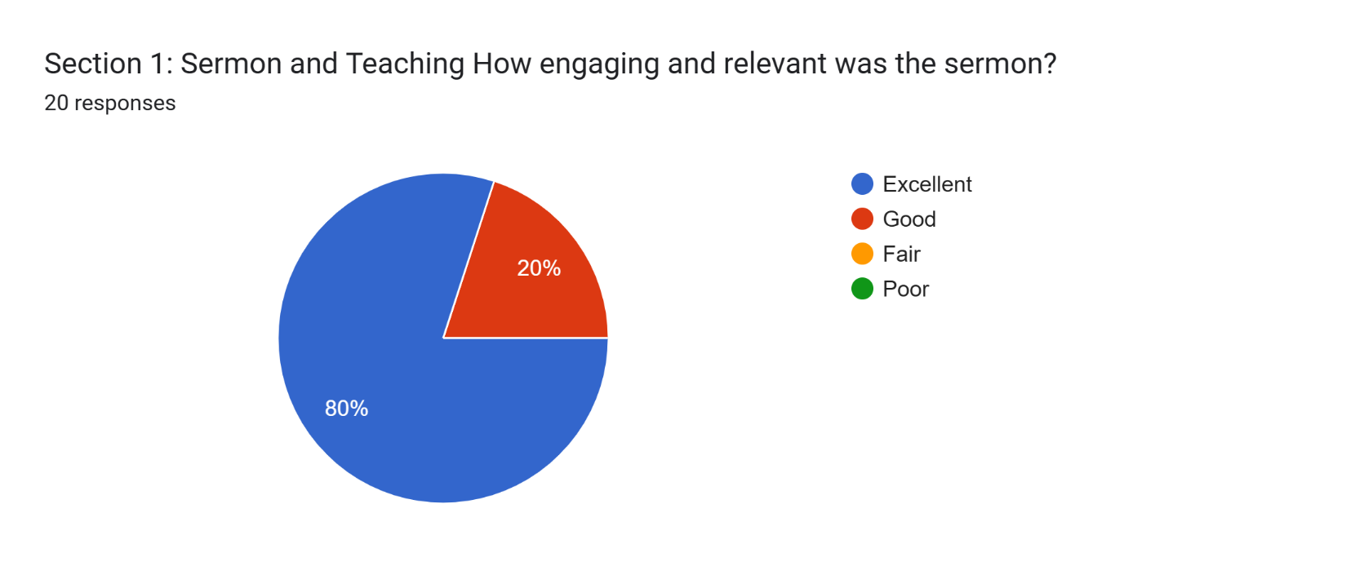

Section 1: Sermon and Teaching
How engaging and relevant was the sermon?
Add any comments here ...
18 responses
John seemed very comfortable.

Interesting how John used Lamentations to remind us of God's faithfulness. It is clear that John is a seasoned preacher and can deliver a message. He made the topic interesting, bible-based, and challenging. Class was equally well delivered and Bible based. A good combination of teaching and interaction with the class.
God's faithfulness in the storm, applicable to our anxieties

His presentation was very polished.

Very good delivery

John was able to engage the congregation with questions, funny comments, and was able to stay moving around the stage well.

I appreciate that John has stronger speaking skills. He clearly has more experience with sermons. I personally do not like the more traditional Southern style church of Christ cadence, intonation, and "loudness" that he appears to represent. (But that is my own opinion.) I'm sure many who come from traditional church of Christ background find him very familiar and safe. Although Jason's sermon was not polished, it was heartfelt. I thought he tried to connect to the congregation over a mutual sense of suffering and struggle, and offered compassion, prayer, and being in the presence of God.

Lamentations is my new favorite book of the bible. Very engaging and easy to listen to.

I thought it was really good and well delivered

I feel John has a true gift to get the message across. He was on topic and very comfortable in front of a group. The week before, when Jason preached, he wasn’t as comfortable. That being said, I do think he will probably get there the more he preaches.

Kept to the subject and gave relevant scriptures

Presented like a seasoned pulpit minister.

Sermon was engaging and relevant. He had a warm presentation.

Grabbed me right off the bat. Great sermon!

John was very good at communicating to a new audience. His messaging was both positive and on point. He was also very easy to hear and understand!!
Excellent

John is a trained and experienced pulpit preacher. He can really bring a message. If we want a pulpit preacher he is the better choice. But for all his preaching excellence I expect his doctrinal style would alienate the young people who we hope to attract and retain.

He was very engaged with the congregation. A very good public speaker.

Section 1: Sermon and Teaching - Was the message clear and biblically sound?

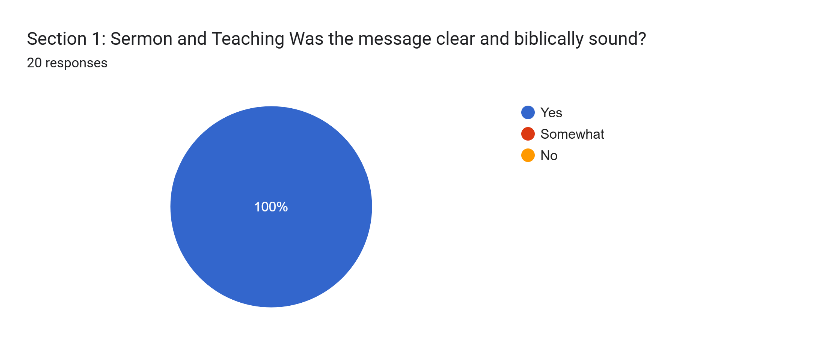

Section 1: Sermon and Teaching
Was the message clear and biblically sound?
Add any comments here ...
12 responses
Lots of scripture references.

Sermon followed the text in Lamentations (with a few additional support scriptures). It was not a topical sermon that used a few cherry-picked verses to make a point.
repetition of key points and support in scripture

Yes, his sermon was biblically sound and clear.

Very well thought out message

Yes, his sermon on lamentations boiled down to the take away: In the face of a storm --Remember, Repent, and Renew.

He started Bible study with a song and said he likes to start that way to get people engaged.

Yes

Didn’t fall asleep

Good sermon

His sermon was well organized and well presented. The man is a preacher. I'm just not sure that he is the right choice for our congregation.

He did a nice job incorporating a lot of scripture with stories and life application.

Section 2: Connection with the Congregation - How well did the candidate relate to different groups in our church?

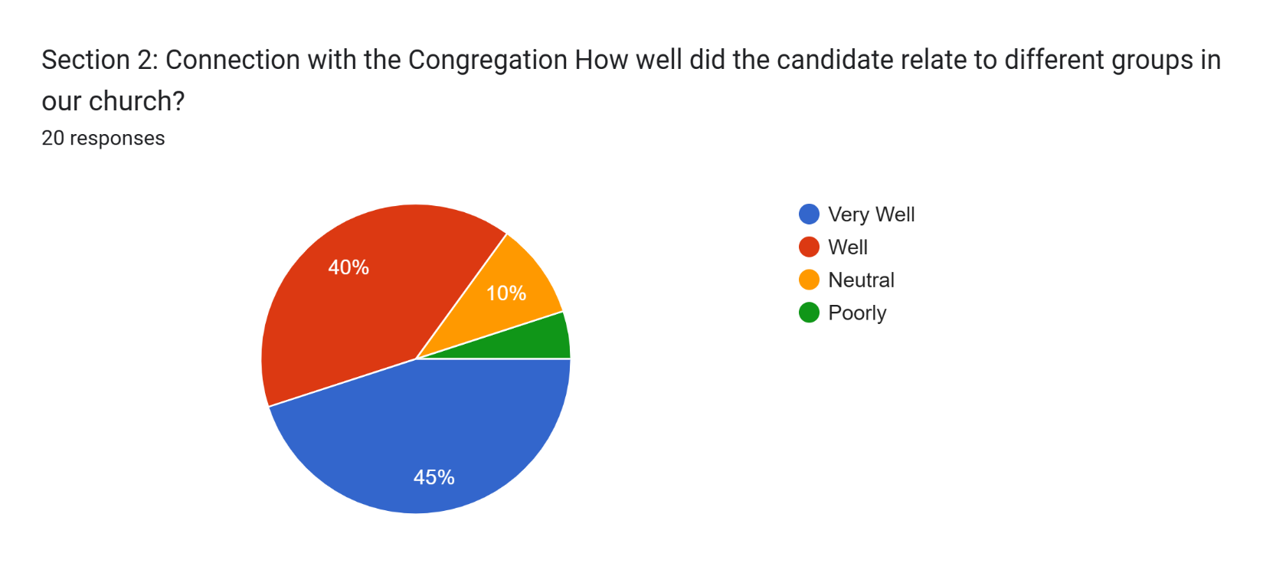

Section 2: Connection with the Congregation
How well did the candidate relate to different groups in our church?
Add any comments here ...
12 responses
John is a personable guy and comes across as easy going and approachable. However, he did seem to keep things on the surface (which, given that this was an initial interview weekend, is understandable). We need to make sure we have a minister that can talk at a deep level about the human condition - people that are hurtling, or confused. Can he speak genuinely to the individual (and not just in general to a congregation)?
Based on the people I received feedback from, in general, the older people preferred John. The younger families seem to prefer Jason.

He seemed to connect with all age groups well.

I think he would appeal to those who have been at MX for a long time, in that he brings a familiar presence.

John and Katie seemed well received by the ministry leaders and congregation. John likes to talk, and control the narrative. He has a lot of stories and jokes to tell. Katie seems quiet. Many women did not respond well to John talking "for" Katie and making excuses for her before she had a chance to speak. I personally did not feel like I got to know either of them very well from the dinner w/staff because John talked so much about himself and the people he knew within the church of Christ community. He didn't ask questions about the staff, or the church. I felt the communication was more one-way.

Na

Hard to tell Sunday, but Saturday night we had a nice chat with both.

He related to me and Joanie, and I think he would relate to our age group. Can't speak for other groups in the church, but I think he would relate to them as well.

Engaging

John showed that he has an out- going personality and we think he would be able to relate to all groups.

Good

John is coming out of a very traditional church of Christ background. I don't see him relating well to our diverse congregation. He describes sedentary activities. His interests consist of food and restaurants, watching football and deer camp. I don't think these activities will relate well to the people at McKnight Crossings.

Section 2: Connection with the Congregation - Was the candidate approachable and personable?

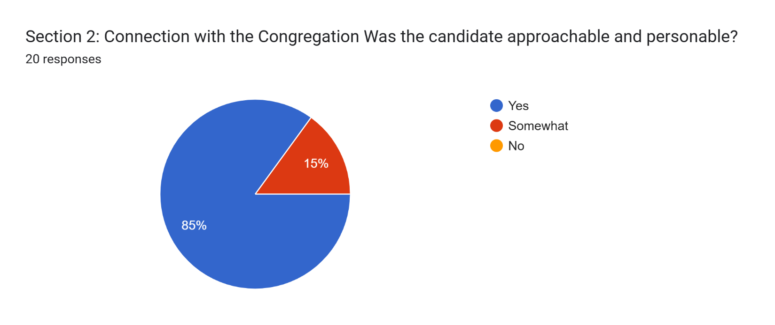
Section 2: Connection with the Congregation
Was the candidate approachable and personable?
Add any comments here ...
11 responses
Seemed like many folks were chatting with him.

You can tell John is used to interacting with people. Again, not sure how easy it will be to get to know him and his wife deeply.

friendly and conversational

John was very personable and approachable.

I think John and Katie are nice. I thought our church received them well for the weekend. I didn't feel they were as open, vulnerable, and personable as Jason and Megan. I didn't feel like they brought the same energy and warmth.

He seemed engaged with people when he spoke to them.

Na

Joanie felt he was very personable and genuine.

Definitely wanted to connect with us.

Good

John did not seem to be approachable or personable. I believe his doctrinal approach would drive away the people we are hoping to attract to McKnight Crossings. One of our goals at McKnight is to reach the Next Generation and I believe the Gunters would alienate them.

Section 3: Overall Impression - Do you feel the candidate would be a good fit for our church?

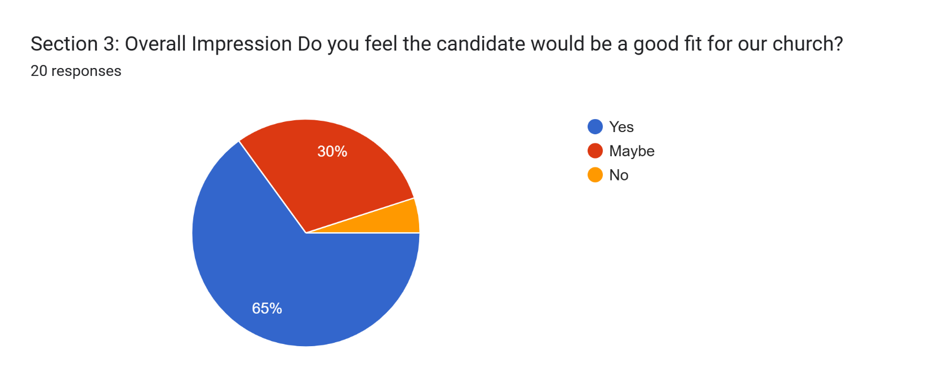

Section 3: Overall Impression
Do you feel the candidate would be a good fit for our church?
Add any comments here ...
16 responses
John would definitely be able to help us maintain. I’m praying to discern if John would help us be flexible and grow.

John knows our faith tradition and the general church of Christ feel. He can resonate at that level with much of the congregation as he brings some of that familiarity.

John impressed me as a traditional COC preacher. I wonder if that’s the approach MX needs. I enjoyed him leading a song prior to Bible study.

John seemed to be experienced in the ministerial role. He seemed to have leadership skills and is a very polished speaker. I guess my question would be, is McKnight seeking a minister that can step in to a leadership role. If so, then John would fit right into that role.

Strong preaching ability…maybe less pastoral than Jason

Potentially could be a good fit for the current state of the church.

I believe John would be a good fit if our leadership is trying to appease the older population at our church. John is familiar to those who harken from traditional church of Christ. When I asked Marisa what she thought of the candidate, she said he was "average" and what she would expect from church. I asked her to get on YouTube and listen to Jason's sermon. She listened to a portion and said "he seems cool." Plus, she liked the thought of a minister with a "man bun." Now, she is eighteen years old :) but the point is.. the younger generation is more willing to listen to someone who looks different, acts different, has a more conversational style of presenting, and appears genuinely interested in them as a person, not a group.

I felt like he was trying really hard to not be ‘Church of Christ ‘by saying various things throughout the sermon and class. Perhaps he was trying to prove he could fit in. Overall, it seems like he would be a strong leader for the people already there. I did detect some southern -polished -church in him and I don’t think that part is a good fit. I didn’t get to respond about Jason so I will here. He seems to be less polished but sincere and authentic. His sermon had a good message but his teaching in class was not effective. I think he would need to grow in preaching which I think he can. I also believe he is the type of person who could reach the younger generations and to me this is a big plus. Overall he seems to be a better fit. However, it’s very difficult to make that call from just a sermon and a class. We do need to pray and fast and Im grateful you are doing that and encouraging the body to do that. Im so glad to part of this body and I believe we are ready to go. I know you have weathered many storms over the last couple of years and I respect that you have stayed the course and trusted God to sustain you. I am thankful that you serve well for our body of believers

I thoroughly enjoyed his sermon and lesson afterwards.

Yes, definitely. You could tell he has been a pulpit minister for years. Only the elders can tell how he would work with the staff and leaders. Katie is a great asset too.

We feel like he would be a good fit for our congregation. We were impressed with his preaching and teaching, and he seemed to be a kind and caring person. We feel he would draw people to McKnight.

Much better than the last guy.

Family man with children, and young enough to relate to both young and older generations.

Good fit

We need to ask ourselves what direction we want to go. If we want a doctrinal pulpit preacher then John is our choice. If we want a shepherd who can relate to people then Jason Mundie would be the better choice.

He appears to need less coaching possibly than Jason but Jason is tender hearted and moldable. I think John would adapt more quickly but may not be quite as appealing to the younger generation. I think Jason would challenge our thinking and be more outwardly evangelical. I don’t think we can go wrong with either of the men.

Additional Thoughts or Concerns

Additional Thoughts or Concerns
Please write any other feedback here:
12 responses
John is solid and capable and somewhat old school in his sermon and class. I don’t know if that will help attract seekers and young families or not. It may be the solid base they are looking for, or it may be a bit unrelatable. Need to keep praying.

John can hit the ground running. He is a seasoned minister and can handle preaching and teaching. However, can he connect deeply with the members of the body? Can he challenge the congregation to step out in new ways? Can he speak to the younger generation? During the weekend with John I didn't get a clear sense of his vision for the Church. John's wife, Katie, is shy but friendly. She admitted her gift is not being out front or leading a ministry. However, she is happy to support. Is John looking to work at another church because he is feeling God's calling to a special work or opportunity to server, or is he just looking for someplace better than where he is currently at?

One of my concerns was the dynamics with his wife. At times, his interactions seemed controlling and belittling towards her.

John's strengths would be his leadership and experience. However, is his background in a more conservative Church of Christ and if so, would he be feel comfortable at McKnight. He would also be new to the STL area, so there would be a learning curve for community involvement, including young adults, college age and possibly STL diversity.

The two candidates are very different. I appreciate the leadership for seeing strengths and potential in both. I personally feel that John is too traditional and "expected." I have been at McKnight since 1996 and feel this style of preaching would be a step backwards in time. I think Jason would need some additional coaching and encouragement by the leadership for his sermons, but as far as his relational approach to life, interpersonal skills, and sincerity, I think he has an advantage over John. (Just my humble opinion.)
I did not fill out the survey for the first candidate - but I feel that they would both potentially be good fits. I'm sure you've thought of this, but maybe experience as a lead pastor (John) would allow him to hit the ground running faster than experience as a campus youth minister? I liked them both pretty much equally - and both were good sermons.

Jason and Katie were both very personable.

Of the two candidates, John is my choice. However, if they are offered the position and turn it down, Jason & Megan would be acceptable.

If I had to make the choice, I would choose mr. Gunter

We think John would be a good choice for our head minister.

I do not believe MxCrossings can go wrong with either candidate. John is eloquent & will attract an older and more traditional CofC crowd . On the they hand, Jason speaks from the heart & will attract a younger more progressive crowd. The elders will need to pick the direction the church should go. Either way, I trust God’s ability to work his will in this church.

The first couple, Jason and Megan Mundie, are approachable and personal. They are more diverse, energetic and active. Jason preaches in his church and also leads a college ministry. I believe that our God is a god of relationships, compassion and mercy, not dogma. I see Jason as the man who can bring in and retain new members with his caring personality. I can see him relating to the next generation which has been one of our goals as a congregation.

Candidate Preference

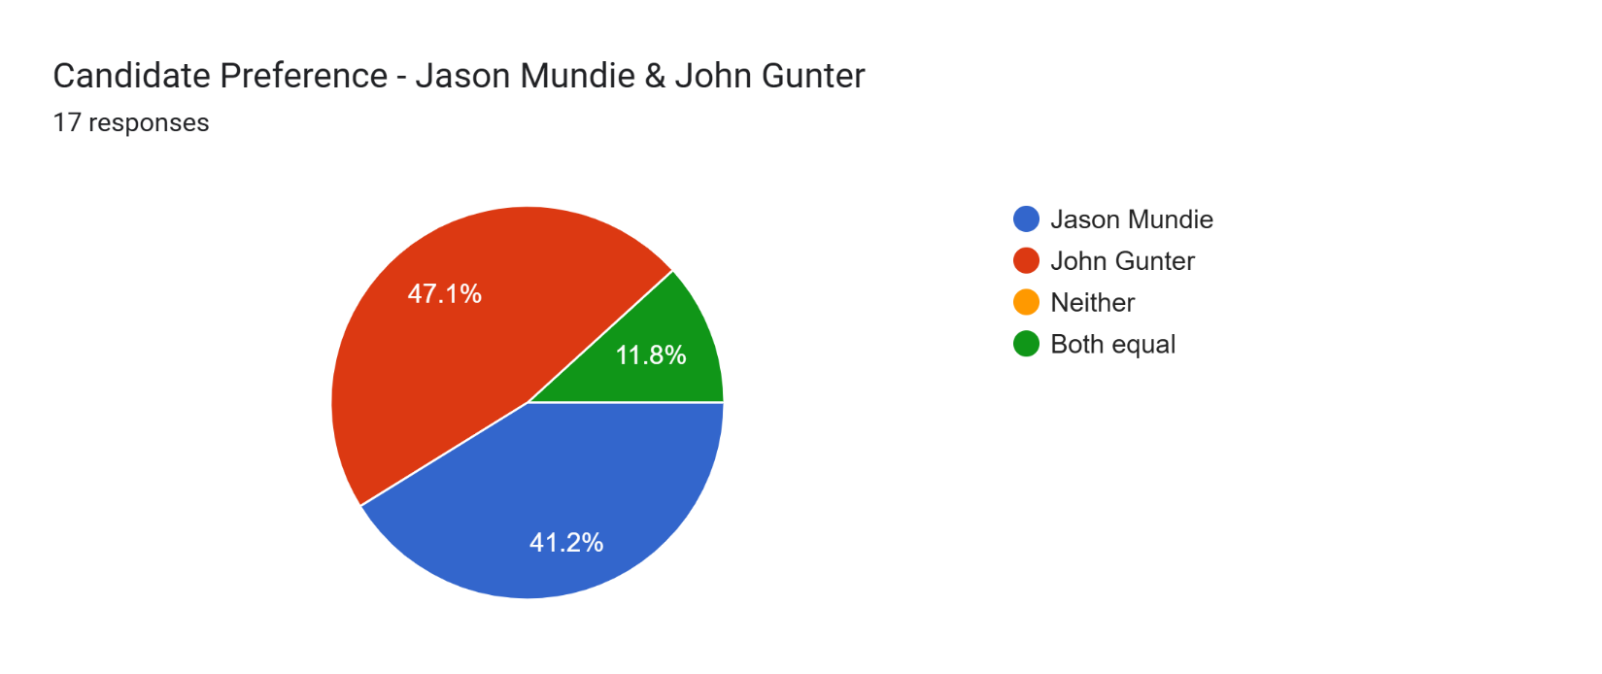

Candidate Preference - Jason Mundie & John Gunter

We hope you have made the effort to meet and listen to both candidates and provide feedback on each. After considering both candidates do you have a clear preference? Do you have any concerns or reservations about either candidate? Do you feel either candidate would be a bad choice or problematic for McKnight Crossings?

Please provide your thoughts below:
12 responses
I like them both and either would provide good lessons and leadership and be a great addition to the MX family.

I guess the question I ponder would be "are we seeking someone like John, an experienced minister to take over the leadership role immediately, or someone like Jason that might be more inexperienced but might be immersed into diversity and attracting young adults to the congregation". Both are excellent candidates, but I think that I would lean toward John simply due to his experience and leadership in leading a congregation. However, I would be happy with either candidate. I want to thank the Elders for their diligent work in our minister search.

I strongly believe both candidates could be a good fit for us. I feel John is a better preacher than Jason. I feel Jason has a stronger pastoral heart as his strength. Based on their respective personal situations it will be a sure for John & Katie to accept and move here than for Jason & Megan…all other things equal. If pressed I would lean into John & Katie…but believe either could be a blessing to us.

I feel I am leaning more Jason at the moment. I've been seeking wise counsel to fill the gaps where I might miss things about the candidates. I truly like both guys and think either could do the job. I resonate with Jason in that he's never been a full time preacher, the same way I was never a full time youth minister. I think he has some growth to do, but I think especially with his background in campus ministry, he could be an asset to bring in young people. His sermon would appeal to the "mature Christian" as well as the people we want to reach. Jason and Megan both are super genuine and I love their background in the foster care system, a great form of putting faith in action. I think Jason would work well with this staff, and probably have to grow into leading us, but be able to do well. John has more experience, and I even think his sermon was presented better than Jason's. But when I think of the future, I think Jason can be what the church needs. I even think that as we make this push to be a diverse church, Jason would be an appeal to the people we want to reach. I would never suggest hiring based off of diversity alone, but this is a plus. I personally would love to speak with people who think we should offer the job to John so that I can see if I'm potentially missing something. But at the moment, I'm leaning more Jason. I'd be happy to speak to any elders or members who think otherwise! (I would not be angry or opposed to John if Jason declined. I truly did like John).
[As described in previous sections.]

John is my preference. As I said, I think Jason has great potential and I don’t think it would take long before he is more comfortable speaking to a big group.

John needs more seasoning

Both men seem to be quality persons. Jason was very sincere and open with his life, which was very appealing, but we don't think he would be the best fit as our pulpit minister. We think John's maturity and personality and experience as a pulpit minister would make him a better fit.
Mr. Munde was not engaging. I don’t go to church for a “Ted talk”

See previous answer under comments for John Gunter

I believe Jason & Megan to be our best choice. While John is an excellent pulpit preacher but I expect his doctrinal style would alienate the young people who we hope to attract and retain. I think that the Gunters are looking for a way out of their traditional Church of Christ. I think that the Mundies are already more diverse and have a wider range of worship experiences that will fit our congregation. I think the Mundies are looking for a way forward, a way to grow. They have a personal, relatable style that will better fit our congregation and our culture in St Louis.

They are equal but different in different ways.

Excel Spreadsheet of Google Form Survey
Responses noted above are also available in an Excel spreadsheet here - https://www.shepherd.mx.mxcoc.xyz/positions/docs-24/MX-MinisterCandidate-JohnGunter.xlsx.

