How to Access Allegro remotely
- Right-Click “Microsoft Icon” 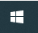 from right-lower corner of your computer screen – click
Run” - type “mstsc” in Open field, click “OK” button

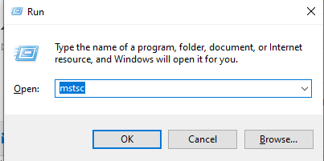

- Type “STLPALTS00” as computer name in Remote Desktop Connection window. Click “Connect”

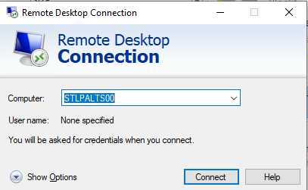

- Enter your Arch Network credentials
- There should be a “Allegro” shortcut when you login
- When you are done working with application, please click “Microsoft Icon” – click “Sign Out” to logoff your session.

