
Allegro Deal Capture System
Key Trading and Price Capture Flows

Purpose:
Documenting the key usages of the Allegro deal capture system. Understanding of use is import should the application no longer be needed to maintain trading or hedging positions.

Summary:
Should Allegro no longer be needed for deal capture the daily price import feature will still be required. It is possible for the daily price import functionality to be processed without Allegro but the build-out of the LIM Interface module will take time.

Allegro: Key Process Narrative
As noted in Exhibit A Allegro is used for three main processes:

- Obtain Daily Prices – used for …
  - Weekly management reporting on price movement
  - Feed other systems: RMS, OFA, CT, etc.

- Main record of trading deals
  - Front-Office Trading (speculative positions)
  - Front-Office Hedging
  - Treasury / Finance Hedging
    - Operations diesel expense
    - Interest rate swaps/hedges
    - FX currency hedges

- Daily mark-to-market valuation (MTM PnL): Multiply 1. X 2.

If Arch no longer needs a trading desk then items 2. and 3. Above are not necessary (or can be done on an Excel spreadsheet on a one-off situation). Regardless of the decision to continue trading there will remain a need to obtain daily prices.

- Price Discovery
Allegro utilizes the price consolidation services of Morningstar, previously designated as the LIM interface. Morningstar will collect prices from multiple sources – brokers, exchanges, publications – and send them in a specific format to Arch when requested. This allows Arch to manage a single API with Morningstar instead of multiple API interfaces with each price source.

Prices that will be pulled daily via Allegro first need to be set-up using the LIM_INTERFACE and corresponding RMS form. See Exhibit B. Once prices are set up then Allegro can run a Connection at a specific time to start a stored procedure created by Arch IT (see Exhibit C).

The LIM interface will load the prices into the ALLEGRO.PriceValue table (see helpful SQL at Exhibit D)

Consumers of Price Data
After data has been received by Allegro (via the LIM interface with Morningstar) the data will be used by various systems and processes. Most all pull the data directly from the Allegro.PriceValue table.

- Allegro : prices are used for the daily valuation calculation where open positions are multiplied by price change (today’s price less prior day price).
- Business Objects : prices are pulled into the various warehouses for reporting and processing
- Risk Report : This is an Excel VBA process that extracts data, including price data, from various reports – primarily Business Objects reports (see above)
- RMS : The revenue management system links directly to Allegro to obtain price indexes quoted in indexed based deals. RMS has a drop-down that is directly from price indexes located in the Allegro database.
- Coal Sales Invoicing : Tim Schroeder and Sue Prader will use Allegro price data for month-end invoicing of indexed based contracts.
- OFA / OMAQ / CT : Allegro indexed prices are pulled into the various “Simpson Brother” applications and used for pricing, netback calculations, and forward modeling.
- Weekly Price Charts : Weekly the Allegro prices are used to present key market price trends to Senior Management.

- Deal Capture
Allegro is the system of record for derivatives (speculative or hedging transactions).
- Front Office Trading – speculative positions: Arch has used industry experience to take advantage of commodity price movements. These are speculative positions not associated with any contracts or production volumes.
- Front office Hedging : Derivative transactions can be used to hedge any indexes based contracts or future production tons.
- Treasury / Finance Hedging : The Treasury department has the ability to use derivatives to hedge the following …
  - Operations Diesel Expense : Diesel fuel is one of the largest mine expenses, especially at the Western operations. Hedges (usually in Heating Oil) can be used to minimize the risk of price increases
  - Interest Rate Swaps/hedges : infrequent, but Treasury can also use derivatives to hedge bond exposure to interest rate changes
  - FX Currency Hedges : infrequent, but exposure to foreign currency like the Australian dollar can be hedges using FX derivatives.

The above are usually effectuated and entered by the Front Office, but direction and approval comes from Treasury / Finance. Although these deals are in Allegro the Accounting office (Jeanette Cover) is responsible for the monthly mark-to-market valuations used for reporting.

- Consumers of Allegro Valuation Data
- Daily Risk Report : When there are open trade/hedge positions the Allegro system will create a daily MTM-PnL. These numbers are used to assess margin cash requirements and report on value at risk (VaR).
- Derivative Accounting Info : At month / quarter / year-end the derivative valuation information is presented to Accounting (Tim Schroeder) for inclusion in the G/L and financial statements.

Exhibit A
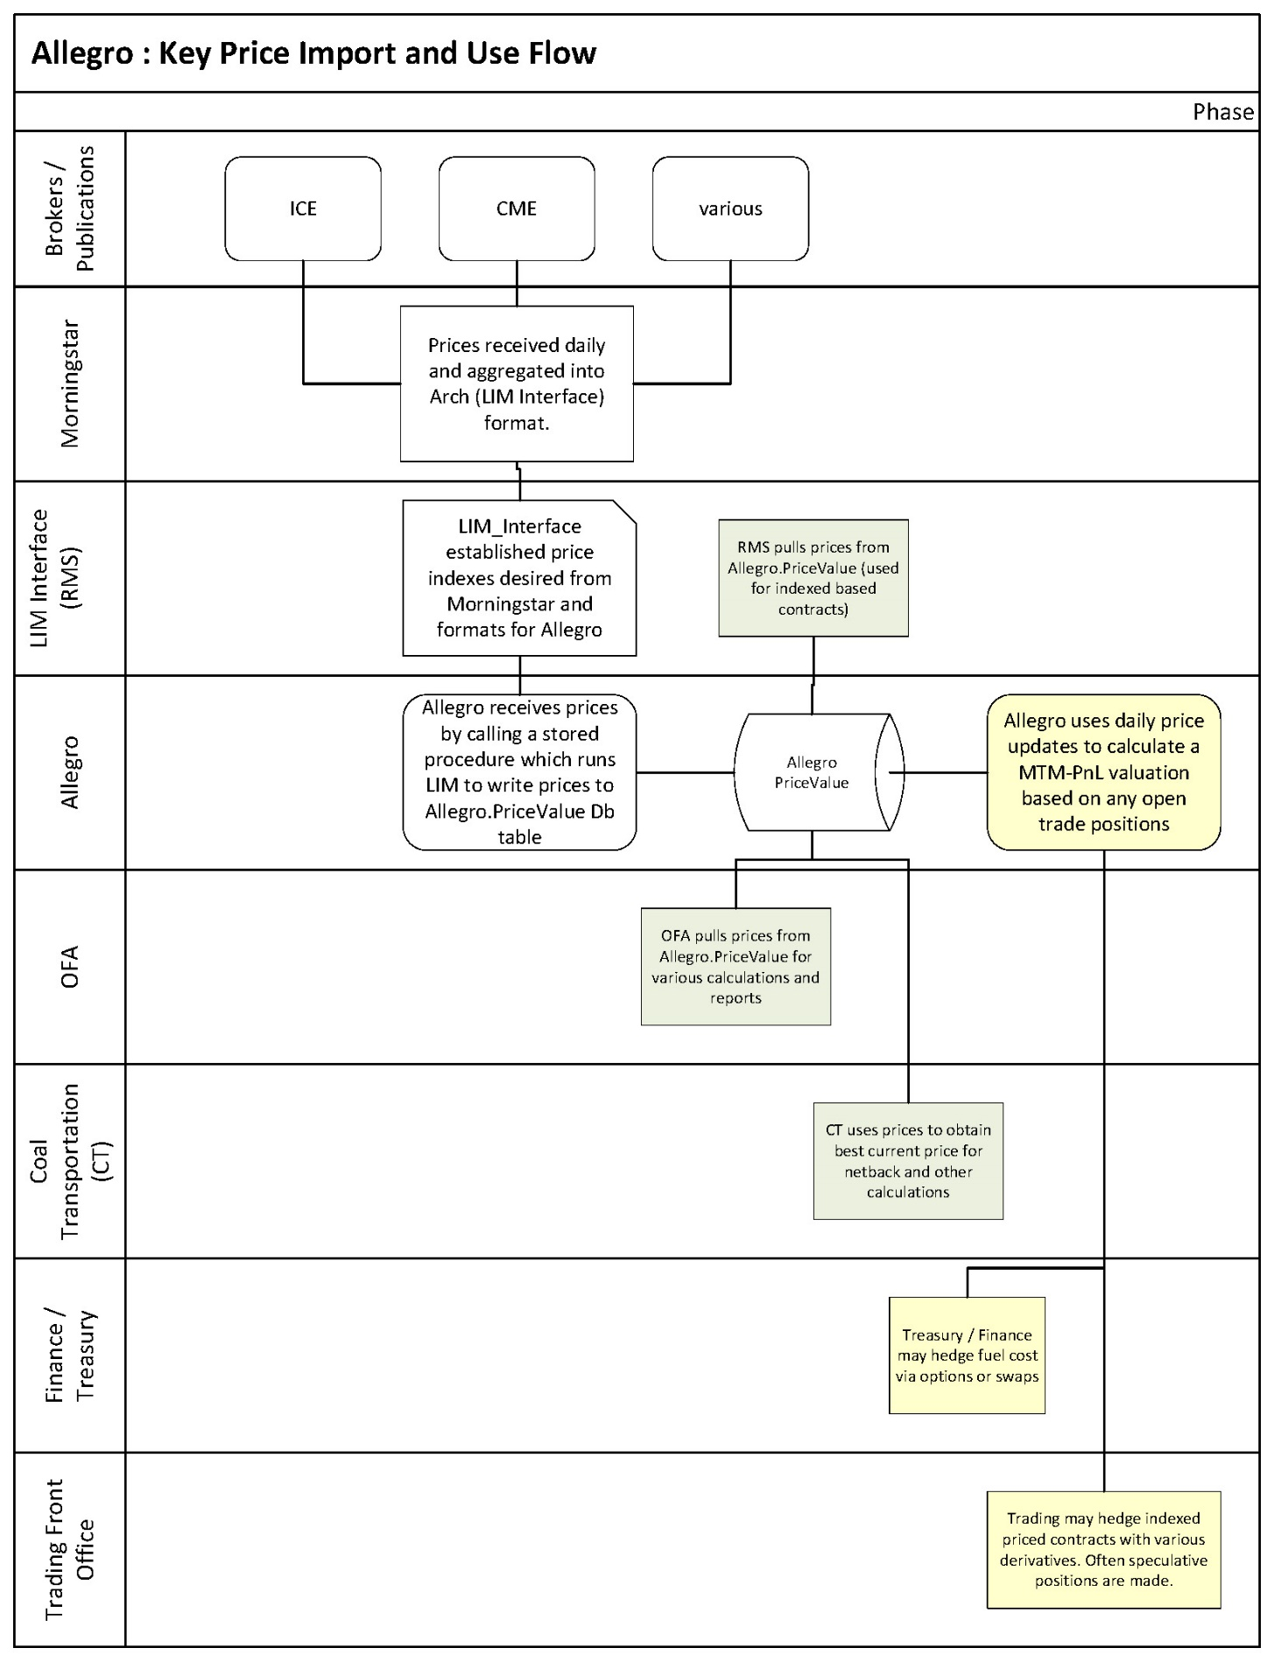

Exhibit B
Click Risk Management Click Maintain LIM/Allegro Interface

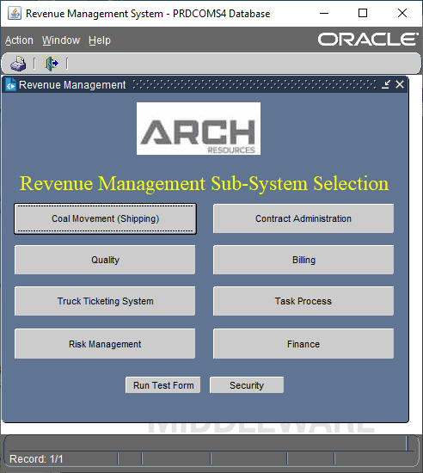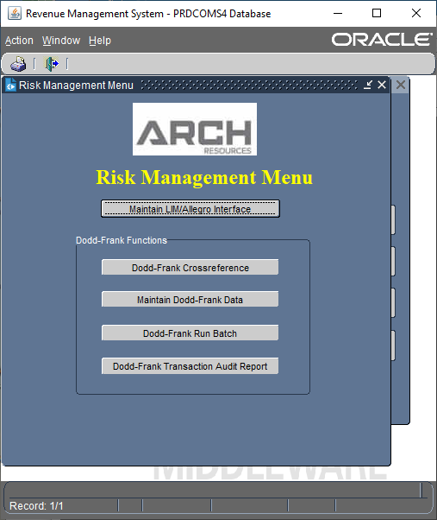

Below is the LIM Interface in RMS
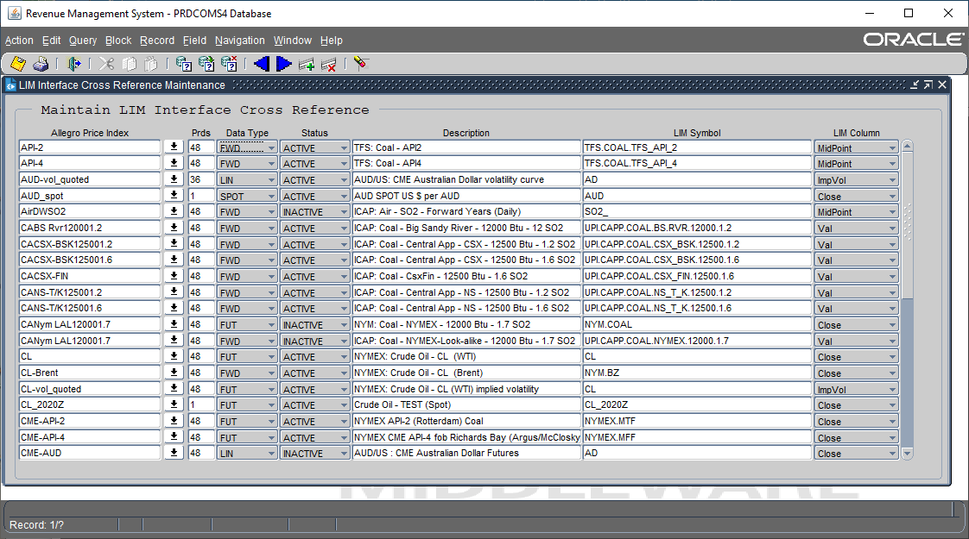

Exhibit C

Below is the Connection started each day at 7:37 pm. The Connection will call the following SQL:
- Begin; execute allegro.arch_pricing_wrapper ; end;

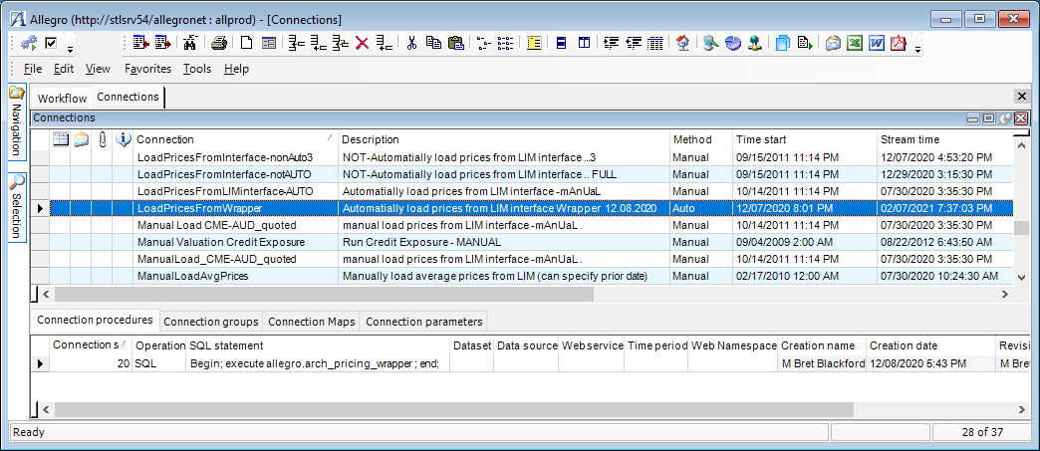

Exhibit D

Key SQL for Querying Allegro Price Information

/* below gets latest prices loaded in the the PriceValue table */
select apv.PRICEINDEX, apv.PRICEDATE,
apv.DELIVDATE, apv.PRICE, apv.CREATIONDATE
from ALLEGRO.PRICEVALUE apv
order by apv.CREATIONDATE desc;

/* Formatted on 02/08/2021 2:56:23 PM (QP5 v5.336) */
SELECT * FROM LIM_INTERFACE.LIM_INTERFACE_CFG;

/* below shows logging of most recent attempts
to pull pricing data back from the LIM_INTERFACE */
select *
from LIM_INTERFACE.LIM_INTERFACE_LOG lil
where lil.INSERT_DATE >= (SYSDATE - 1)
order by lil.PKEY desc;

/* below shows the current valid indexes (LIX_INDEX_NAME) */
select *
from LIM_INTERFACE.LIM_INTERFACE_XREF xref;

