McKnight Crossings Electric
Original Main Panel

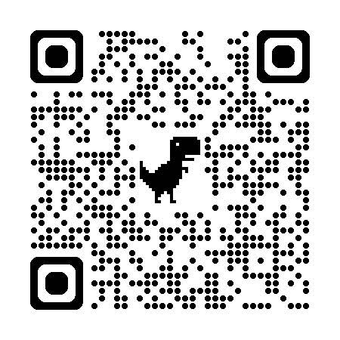
Use QR code for breaker detail

Electric Blueprint QR below
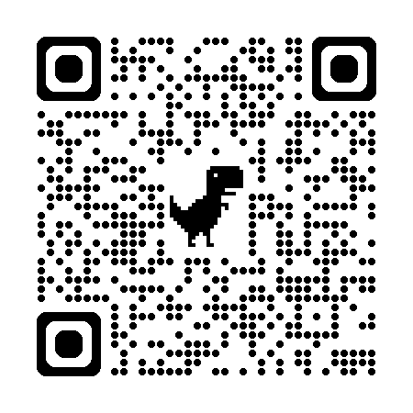

McKnight Crossings Electric
MSDP – Main Service Distribution Panel

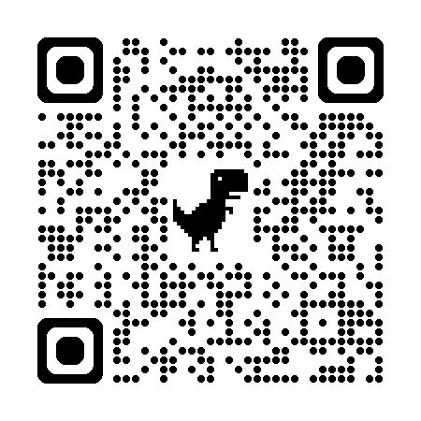
Use QR code for breaker detail

Electric Blueprint QR below

McKnight Crossings Electric
Panel A

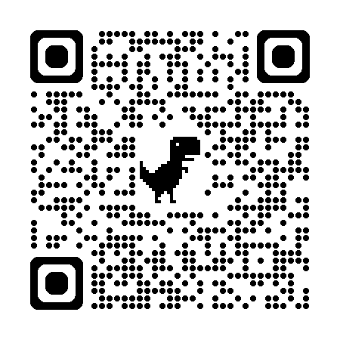

Use QR code for breaker detail

Electric Blueprint QR below

McKnight Crossings Electric
Panel B

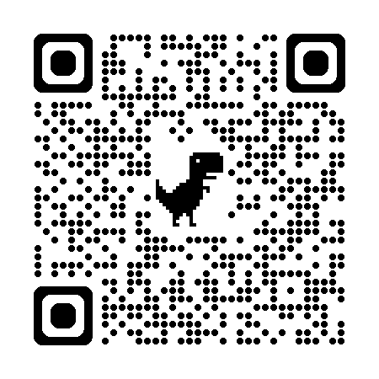

Use QR code for breaker detail

Electric Blueprint QR below

