Memorandum prepared by M. Bret Blackford on April 19, 2024

Purpose:
To document the user access controls associated with XFA

Background:
Oracle Financial Analyzer (OFA) will be decommissioned on April 26, 2024. After that date, key reporting that was sourced from OFA will now come from XFA. XFA Db is a system built on MXSQL and XFA TM (Tabular Model) built using SSAS (Microsoft’s SQL Server Analysis Services).

Access Details:
A. XFA Db server runs on azupmsql02 (azupmsql02.database.windows.net) in the Azure cloud.
The XFA Db is named “XFA”, and as of April 18, 2024 has the following user accounts (see Attachment A):
- dbo
- Excalibur (B)
- Guest
- INFORMATION_SCHEMA
- sys

- Above user accounts 1, 3, 4, 5 are default MS SQL accounts as noted here - https://tinyurl.com/3sa2npx3.

- Above account 2 is used by Tom Simpson, Nathan Woolen, and Chiuchi Chen. All know the Excalibur password (see Attachment A.3.a)

B. XFA TM (Tabular Model) runs on azure://northcentralus.asazure.windows.net/acianalysiservice
This is a SSAS (Microsoft’s SQL Server Analysis Services) that runs in the Azure cloud. Some information on this technology is noted here - https://tinyurl.com/4refbvh4 and here - https://tinyurl.com/mr8jtjya. accounts (see Attachment B)
- My understanding is that only Tom Simpson and Nathan Woolen can make changes to the XFA TM environment.

Overall XFA / Excalibur flow noted at diagram at Attachment C.

Attachment A.1
Below listing provided by Tom Simpson on April 19, 2024

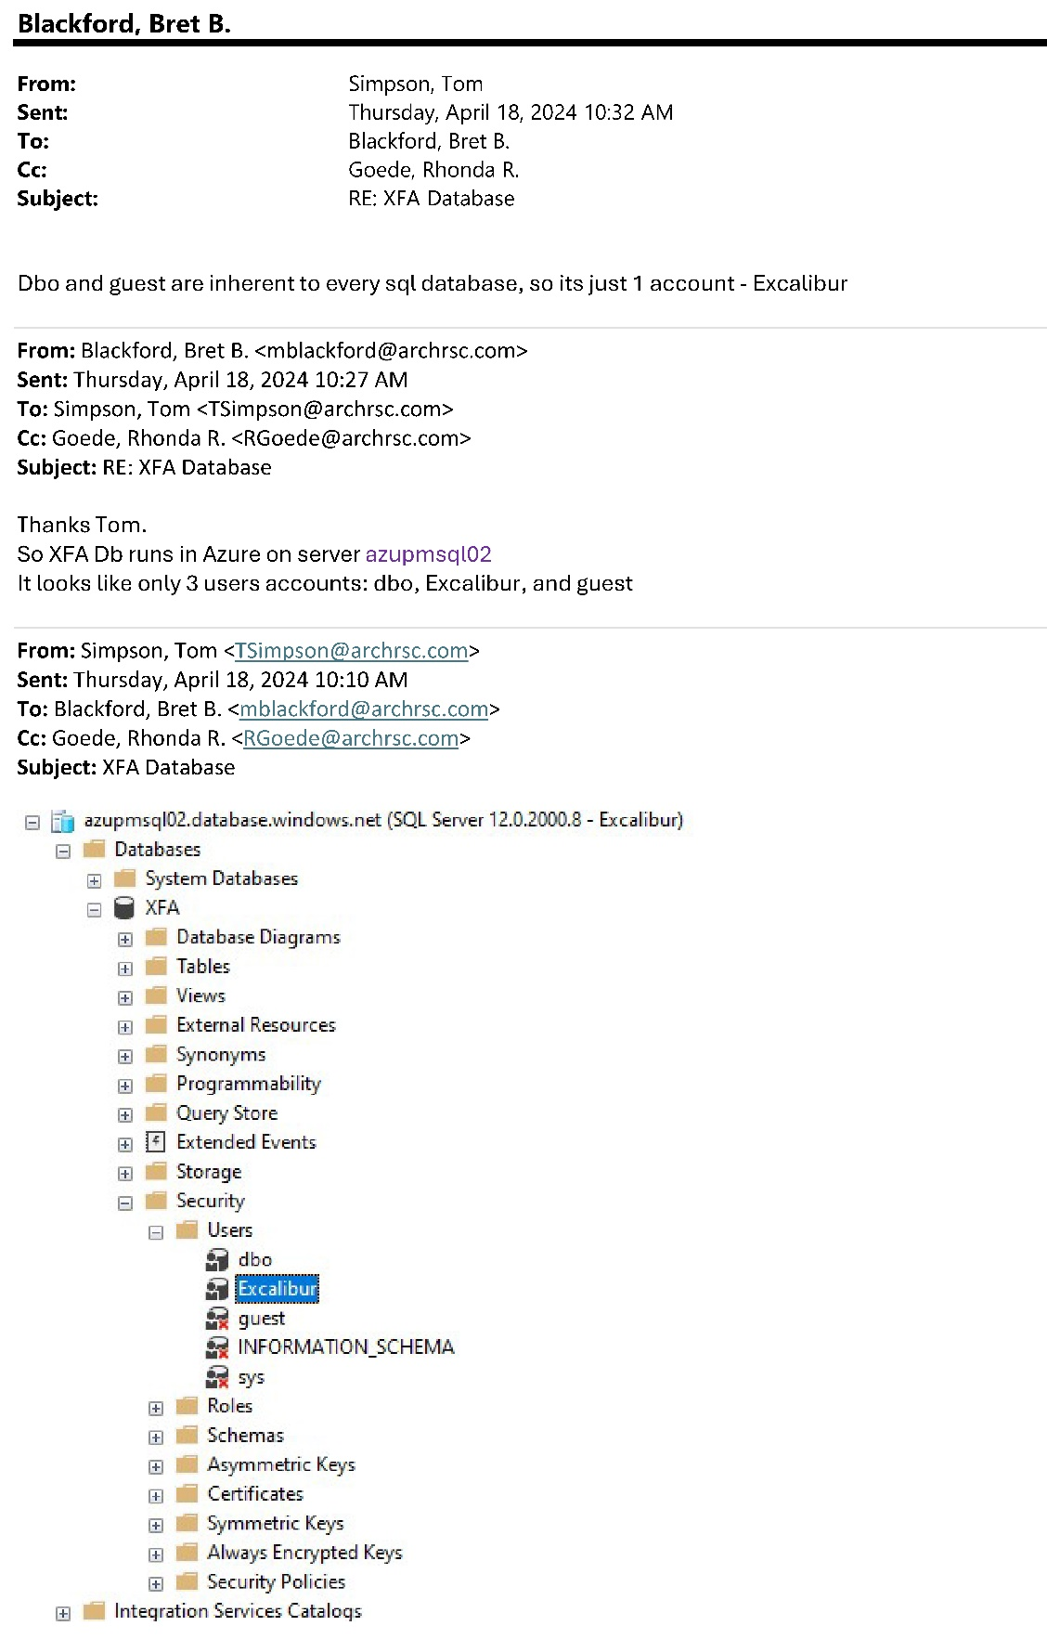

Attachment A.2
Below listing provided by Chiuchi Chen on April 17, 2024

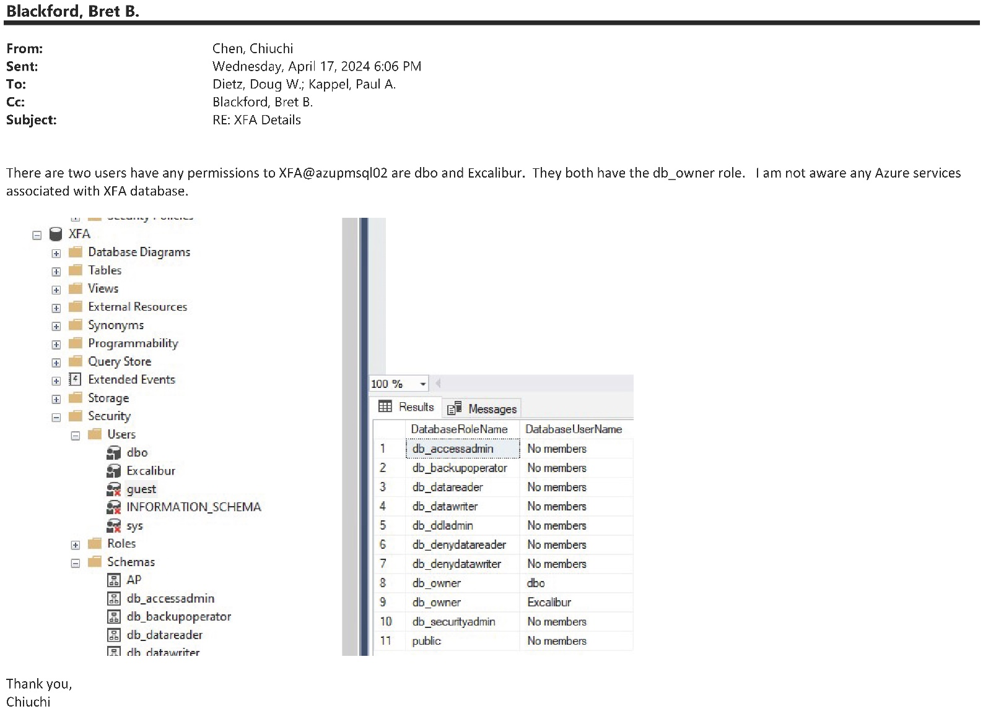

Attachment A.3.a
Below email from Chiuchi Chen
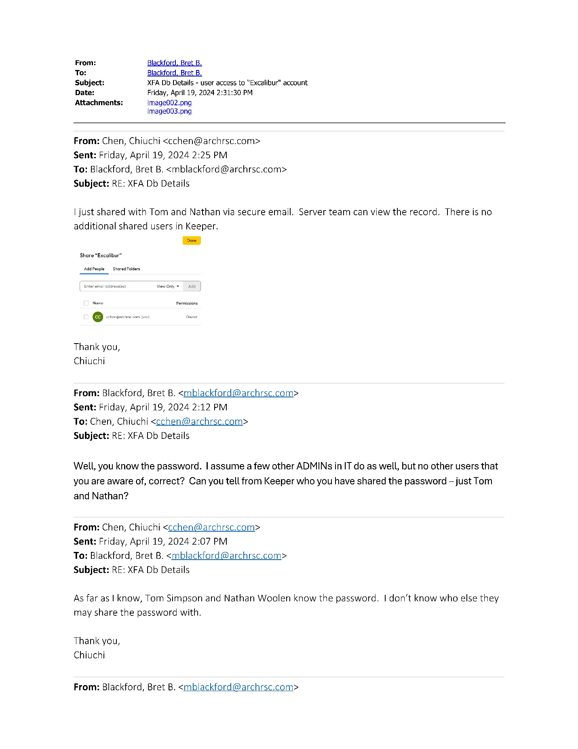

Attachment A.3.b
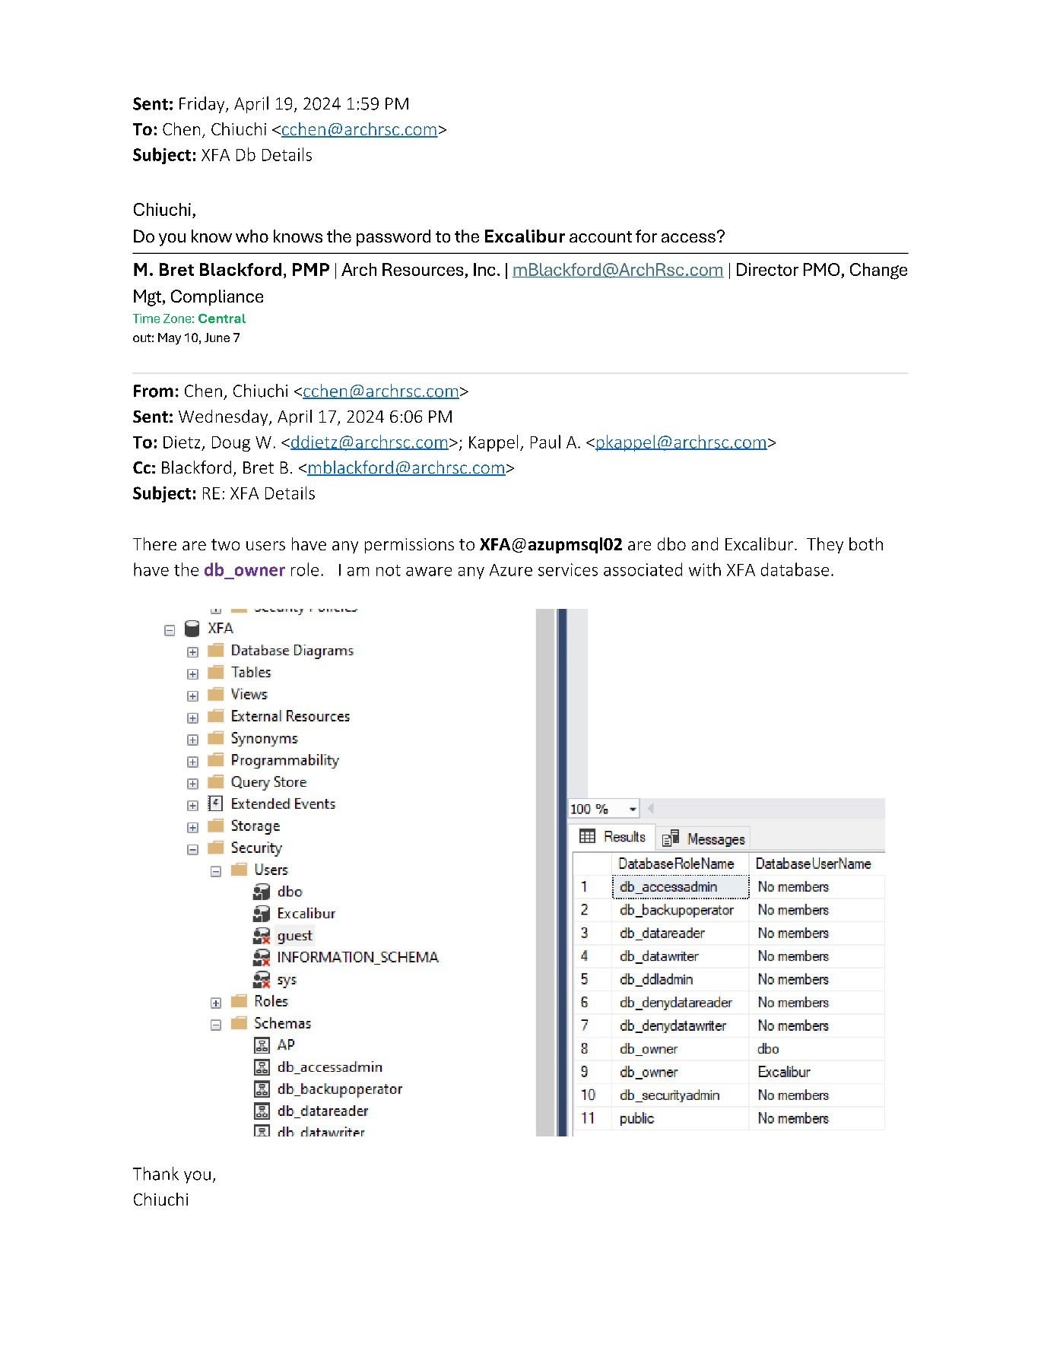

Attachment B

Below from Tom Simpson as of April 19, 2024.

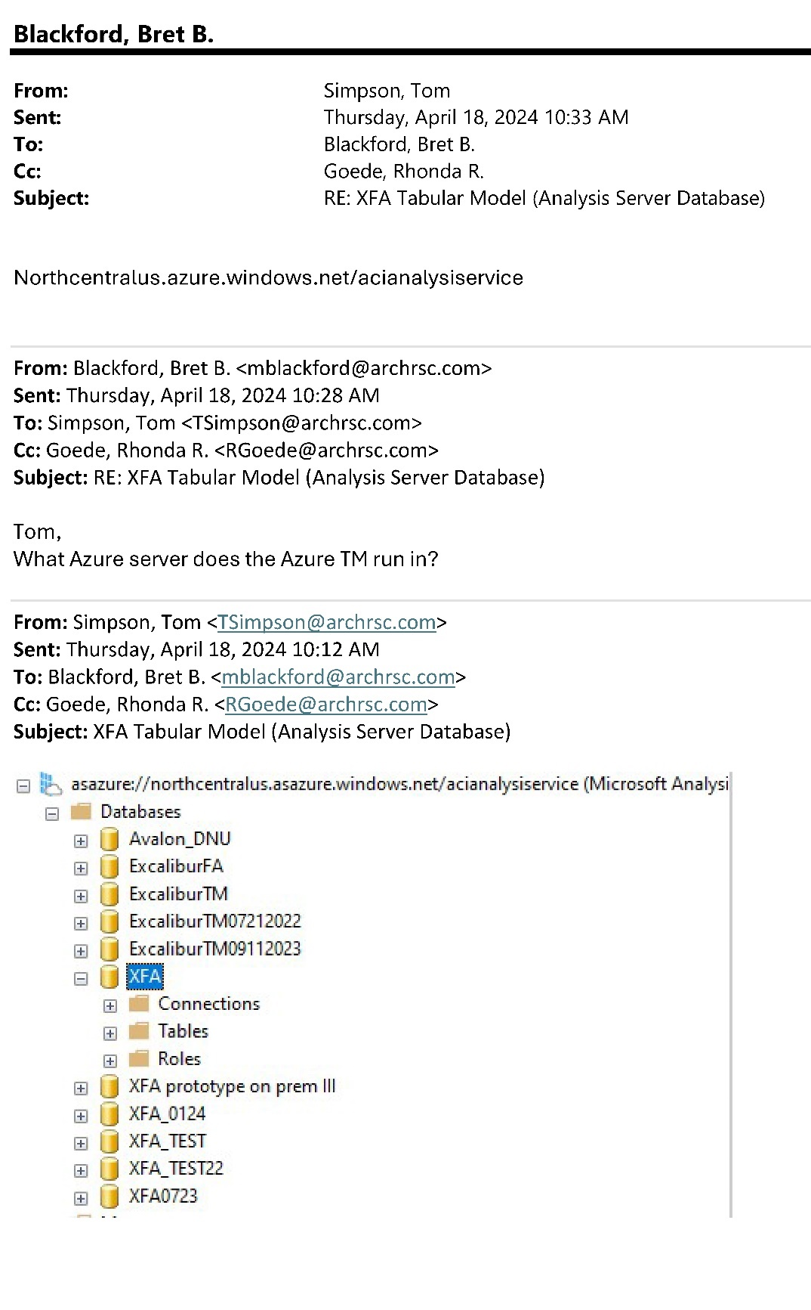

Attachment C
