Prepared By: Steve Duncan
Date: September, 2024
Incident of Record: INC0094740

Application Background:
ServiceNow is the main enterprise software used for Service Requests of all types: Change, Problem, Incident and User Requests are submitted and managed through this tool.
User access is complex but broken down mainly into 2 categories which must be reviewed.
Administrative access are those who can modify requests and workflows.
ITIL access are those who can play a role in the lifecycle of a request.

Review Process:
- Annually, the Change Coordinator (Steve Duncan) will execute 2 reports:
  - Active Admin User List
  - Active ITIL User List
- The Change Coordinator will send the Admin user listing to the CIO (Marty Zambo) for approval. Marty is responsible for ensuring change requests as appropriate.
- The Change Coordinator will provide the approval of the access granted to the CIO so that there is no conflict of interest with that approval
- The ITIL user listing will be broken into individual reports by approving manager to be sent to those managers for their review and approval. Each manager is responsible for submitting any change requests as appropriate.
- Any change requests received are acted upon – formal form will be submitted (standard Change Network User Request form in ServiceNow portal) requesting user access change or deletion.
- The Change Management Coordinator (Steve Duncan) will ensure all user access has been addressed and follow-up on any non-responses
- Documentation will be maintained supporting the annual user access review (UAR) and forwarded to the Director of IT Compliance (Bret Blackford) once all documents are received. Bret will do a final review to ensure completeness and then file documents which will later be supplied to audit as requested.

Below shows how to access the 2 reports generated as part of this review.
In ServiceNow, under the All application selection, type in ‘reports’ in the search bar and then select Reports > View/Run.
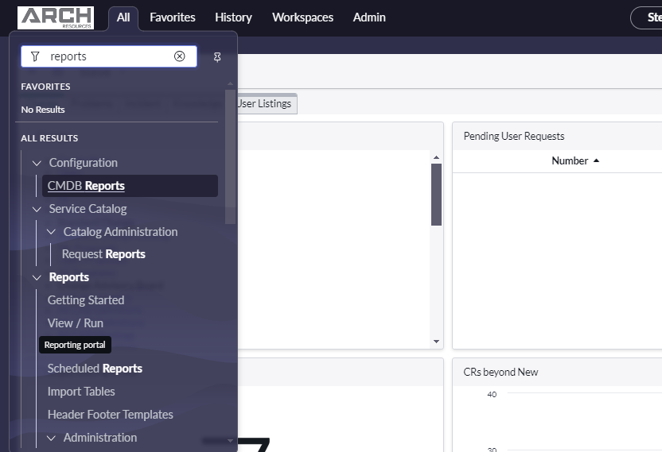
Under the listing of reports, select each of
  - Active Admin User List
  - Active ITIL User List
On each of these reports, Click on the Sharing icon and select Export to PDF:
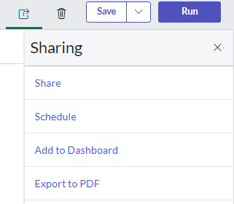
On the same screen, right click in any of the column headers and select Export > Excel to generate an Excel spreadsheet of the report
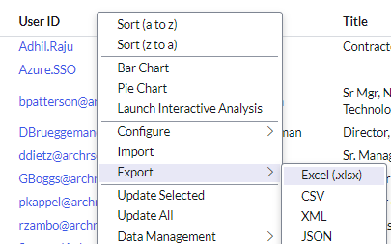

Support documents:
# | Description | Email Sent | Response Received
1a | Initial reports to be reviewed  - ServiceNow ADMIN users  - Raw from ServiceNow
1b | Initial reports to be reviewed  - ServiceNow ITIL users  - Raw from ServiceNow
1c | Initial reports to be reviewed  - ServiceNow ADMIN users  - Processed for review
1d | Initial reports to be reviewed  - ServiceNow ITIL users  - Processed for review
2. Approval Requests
A | M. Zambo
B | B. Patterson
C | C. Staley
D | D. Trani
E | D. LaBell
F | D. Brueggeman
G | D. Dietz
H | E. Natarajan
I | G. Boggs
J | G. Glassman
K | G. Szczepan
L | G. Hensala
M | G. McCoy
N | J. Ball
O | J. Lorson
P | L. Easler
Q | M. Giljum
R | B. Blackford
S | P. Kappel
T | P. Hager
U | R. Goede
V | S. Eastwood
 | Final Listings

